1. 
2. It’s important property of HTTP method according to specification.
3.  
4. 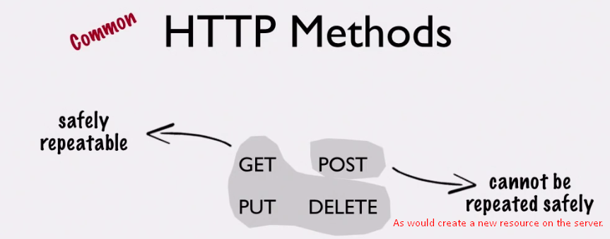  
   The HTTP Methods have standard meaning in RESTful API.   
   If you ignore the standards, you either confuse your clients or cause the code to function improperly.   
   **For Example**: One thing that many APIs do is to cache some of their GET Response.   
   This cache works only with GET Method.
5. If you choose right method for a URI, the client can make a safe-guard to make sure that duplicate request doesn’t happen for non-idempotent method. 